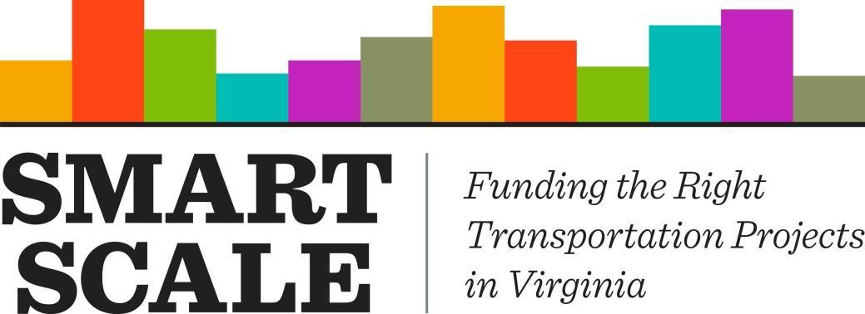

SMART SCALE Project Change Guide

August 13, 2021

Version 3.0

Table of Contents

Introduction 4

Purpose 4

Project Change Triggers 5

Project Change Process 6

Step 1: Identification 6

Step 2: Informal Outreach 7

Step 3: Committee on Project Change (CPC) Review 8

Step 4: Commonwealth Transportation Board Action 9

Monitoring 10

Scope Changes 11

Budget Changes 12

Transparency in the Process 12

Appendix A 13

Scope Change Review Resource 13

Scope Change Review Checklist 13

Project Development Process Check Points 14

Appendix B 15

Illustrative List of Scope Changes 15

Appendix C: Project Change Requested Materials 18

# Introduction

The SMART SCALE Project Prioritization Process (SMART SCALE) informs project selection by comparing a project’s benefits to the project’s costs. The benefit/cost comparison results in a project score that is then compared to other projects both within a District and Statewide. This process is required by state law and supports transparency in project selection.

A project’s benefits are assessed based on scope elements described in a project’s SMART SCALE application. Project scope elements are analyzed on the potential to provide benefits in the following factor areas: Congestion, Safety, Accessibility, Economic Development, and Environmental; a sixth factor, Land Use and Transportation, is also considered in select areas of the Commonwealth. A project’s costs should be based on a collaborative planning and validation process between localities, regional planning partners, transit agencies, and the state; and should reflect the requirements for implementing the project.

*Project Scope*: Per the SMART SCALE Technical Guide, “at a minimum, a scope should define the limits of the project, its physical and operational characteristics, and physical and/or operational footprint.”

Each SMART SCALE application defines the scope of a project through several key inputs; specifically, the short project description, the detailed project description (Rounds 1-3), the State’s Understanding of Scope (SUPS, Round 4), the project location map, the project features, and required supporting documentation (i.e. project sketch and detailed cost estimate). The project’s benefits are calculated based on the inputs as defined by the applicant in their submitted and validated SMART SCALE application.

*Project Cost or Budget*: The project cost encompasses the total costs for all phases of project development and delivery, including, but not limited to, Preliminary Engineering, Right of Way/Utilities, and Construction for highway, bicycle/pedestrian, and TDM projects and other development and/or procurement phases for public transportation projects.

The project’s SMART SCALE budget is the portion of the total cost funded with District Grant and/or High Priority program funds.

## Purpose

For any project selected for funding through SMART SCALE, it is expected that a project’s SMART SCALE benefit/cost score be maintained throughout the project development process. However, project scope and budget changes do occur and, in some cases, are unavoidable. As such, this guidance supports the SMART SCALE Technical Guide and assists applicants, OIPI, VDOT, and DRPT by outlining the policies and procedures relating to SMART SCALE project changes. It applies to all SMART SCALE projects regardless of project administration.

The information provided is not intended to limit flexibility in project design or discourage logical design refinements, but rather provide insight into assessing project changes that may affect a project’s benefits or budget and to document results of these assessments.

## Project Change Triggers

Project changes are framed as increases or decreases that affect the project’s scope, budget, or both.

### Scope Triggers

*Increase*: The addition of any element or feature of a project not included in the SMART SCALE application at the time of project selection **OR** the revision of any element or feature from how it is described in the application at the time of project selection.

*Decrease:* The removal of any element or feature of a project included in the SMART SCALE application at the time of project selection **OR** the revision of any element or feature from how it is described in the application at the time of project selection.

### Budget Triggers

*Increase*: An increase in the SMART SCALE budget in comparison to the SMART SCALE budget at the time the project was approved in the Six Year Improvement Program (SYIP).

*Decrease*: A decrease in the SMART SCALE budget in comparison to the SMART SCALE budget at the time the project was approved in the Six Year Improvement Program (SYIP).

While the above information describes all project change triggers, not all triggers follow the same process. For example, project budget decreases are tracked through the SMART SCALE tracking sheets and the Live SYIP. Budget decreases do not require a project change form. The remainder of the guidance will help explain project change triggers and process in more detail. The Statewide SMART SCALE Project Change Coordinator should be consulted for assistance regarding any questions about project changes.

### Scope Changes

If a proposed project change would result in a scope modification, then the scope may not be modified in such a manner that the proposed improvements no longer accomplish significantly the same benefits as the original scope.

If a proposed project change would result in a scope modification, then the scope may not be modified in such a manner that the proposed improvements no longer address the VTrans need identified in the original project application.

If a proposed project change would result in the addition of significant project features not originally included in the SMART SCALE application and the scope increase does not negatively affect a project’s benefits, then the applicant is responsible for any costs related to the additional scope elements, even if they can be accomplished within the existing project budget.

### Budget Changes

If a proposed project change would result in a budget increase that the applicant plans to cover with non-SMART SCALE funding, then the applicant will need to provide documentation committing to the additional funds, as well as documentation describing the details of the change so benefit impacts can be assessed. For VDOT administered projects the applicant should submit documentation in the form of a letter or email to VDOT’s Infrastructure Investment Director verifying the additional funding commitment. If the funding commitment is local funds then a project agreement would also be required. For locally administered projects the project agreement must be updated to reflect the additional funding commitment. In all the situations described above the documentation must be completed prior to authorization of any subsequent project phases. Delays in updating this information could result in project delays and/or cost increases due to delay for which the applicant is responsible.

If a proposed project change would result in a budget increase in which additional SMART SCALE funding is requested, additional funding may be awardedsubject to the following conditions:

* Budget increase is within allowable administrative thresholds (Item 12a CTB SMART SCALE Policy and pg. 49 SMART SCALE Technical Guide) AND surplus funding is available based on project type and eligibility in the applicable District Grant or High Priority Projects program balance entries in the SYIP. *Within threshold budget increases are coordinated through VDOT’s Infrastructure Investment Division and do not need to go through the full project change process. These increases are documented on VDOT/DRPT DASHBOARD.*
* Budget increase is above allowable administrative thresholds AND surplus funding is available based on project type and eligibility in the applicable District Grant or High Priority Projects program balance entries in the SYIP AND CTB action has occurred approving the additional funding.
* If no eligible surplus funds are available at the time of budget increase, the CTB may elect to use subsequent round allocations to fund a project’s cost to complete.
* Budget increase is not due to added scope.

If a proposed project change would result in a budget decrease, then the surplus funds may not be used to add scope to the project. These funds will remain allocated to the project until award of the Construction (or equivalent phase) contract at which time they will be transferred to the applicable District or Statewide balance entry. Such funds will be reserved to address budget increases on other existing SMART SCALE projects or reserved for allocation in subsequent rounds of SMART SCALE.

When considering any potential project change that may affect a project’s scope or budget, it is advisable to reach out to the Statewide SMART SCALE Project Change Coordinator.

# Project Change Process

The SMART SCALE Project Change Process detailed below is intended as guidance. Any questions regarding potential project changes should be directed to the District SMART SCALE Project Change Point of Contact or the Statewide SMART SCALE Project Change Coordinator.

## Step 1: Identification

The first step in the project change process is the identification that a change may or has already occurred.

### Roles and Responsibilities

VDOT Project Managers and Coordinators and DRPT Program Managers provide day-to-day oversight of SMART SCALE projects. Identification of a project change begins with these parties. The list below details who should be involved at this point in the process. If a project is locally administered, it is recommended that the local project manager is also informed of the potential change.

Active Parties

* VDOT Project Manager or Locally Administered Project Coordinator
* VDOT District SMART SCALE Project Change Coordinator
* DRPT Program Manager
* DRPT SMART SCALE Project Change Point of Contact

Informed Parties

* VDOT District SMART SCALE Point of Contact (POC)

### Process

If a potential project change is identified the first step is informing the District SMART SCALE Project Change Point of Contact for initial review. The District SMART SCALE Project Change Point of Contact will then reach out the Statewide SMART SCALE Project Change Coordinator.

### Outcomes

If the identified change requires further review the Statewide SMART SCALE Project Change Coordinator will begin the Informal Outreach process.

## Step 2: Informal Outreach

Informal outreach is defined as the preliminary research effort between the Districts/DRPT, the Statewide SMART SCALE Project Change Coordinator, the OIPI Project Change Score Review Point of Contact, and members of the Committee on Project Change (CPC), as needed.

### Roles and Responsibilities

The Statewide SMART SCALE Project Change Coordinator and the OIPI Project Change Score Review Point of Contact will manage the Informal Outreach process, engaging members of the CPC as needed based on the change.

Active Parties:

* Statewide SMART SCALE Project Change Coordinator
* OIPI Project Change Score Review Point of Contact
* VDOT Project Manager or Locally Administered Project Coordinator
* VDOT District SMART SCALE Project Change Coordinator
* DRPT Program Manager
* DRPT SMART SCALE Project Change Point of Contact
* Members of Committee on Project Change

Informed Parties:

* VDOT District SMART SCALE Point of Contact (POC)

### Process

The Statewide SMART SCALE Project Change Coordinator will request certain materials to help explain the project change (See Appendix C). The Statewide SMART SCALE Project Change Coordinator may begin the process of engaging CPC members depending on the nature of the change. Additionally the project may be added to the At-Risk matrix, which is described in more detail in the project monitoring section.

### Outcomes

Based on a preliminary qualitative review certain identified changes may be resolved at this point in the process. For example, if a project has a beyond threshold budget increase in which non-SMART SCALE funds are being made available to cover the additional cost and project scope has not changed; then appropriate documentation must be completed as identified in the Project Change Triggers: budget changes section. Once these requirements are met, then the project change is documented and resolved.

In other cases such as, if a potential change would revise the scope from how it is was described in the application; or if a potential change would impact the project’s benefits, or if a potential change needs to go to the Commonwealth Transportation Board, then change review advances to the CPC.

## Step 3: Committee on Project Change (CPC) Review

The Committee on Project Change (CPC) is a cross-functional evaluation team responsible for the review and recommendation of most project changes.

### Roles and Responsibilities

The below list identifies involved parties:

* Department of Rail and Public Transportation (DRPT)
* Office of Intermodal Planning and Investment (OIPI)
* VDOT Infrastructure Investment Division (IID)
* VDOT Location and Design Division (L&D)
* VDOT Traffic Engineering Division (TED)
* VDOT Transportation and Mobility Planning Division (TMPD)
* VDOT District Representatives from the SMART SCALE Project Change Points of Contact

The CPC will include two District Representatives that will rotate on an annual basis beginning July 1 of each year. The representation will include a representative from an urban District and a representative from a rural District.

### Process

The Statewide SMART SCALE Project Change Coordinator will present any project changes to the CPC, with the assistance of the OIPI Project Change Score Review Point of Contact, the District/DRPT SMART SCALE Project Change Point of Contact, and appropriate CPC members.

The CPC team is tasked with the assessment of presented project changes.

* Should a project have an identified scope change; the CPC will review the change to determine if the scope change is a logical design refinement or if the scope change will require further evaluation. When considering the impact to benefits resulting from a proposed SMART SCALE project change, only those factors in which the project demonstrated benefits are reviewed. Moreover, the same planning assumptions will apply as when the project was originally scored (e.g., economic development sites). Should a project need to be rescored it will be done using the scoring factors and methods from the project’s round of selection.
* Should a project have an identified scope change that is determined to be a design refinement or have no benefit impact, the CPC may still request additional review and provide feedback should the proposed scope revision impact or reduce overall project safety from what was initially submitted.
* Should a project have a beyond threshold budget change; the CPC will consider the cause of the increase and any potential impact to the SMART SCALE score and either recommend advancing to the CTB or requiring further evaluation.
* Should the project be under consideration as a potential cancellation; the CPC will consider the cause of for the proposed cancellation and either recommend advancing to the CTB or requiring further evaluation.

### Outcomes

Regarding scope changes, if the CPC has determined that proposed scope change is a design refinement, a scope change with no negative benefit impact, or a scope change with benefit impact but within threshold; then the change will be documented using a Project Change form. The Project Change form will be completed by the Statewide SMART SCALE Project Change Coordinator and provided to the VDOT Project Manager or Project Coordinator or the DRPT Program Manager to be included in the project documentation.

If the scope change results in a negative benefit impact that reduces the project’s score below the lowest ranked project in the cohort of funded projects, then the CPC will consider the proposed scope change and either recommend advancing to the CTB or requiring further evaluation.

Regarding beyond threshold budget increases, the CPC will consider the cause of the increase and either recommend advancing to the CTB or requiring further re-evaluation.

In specific instances the CPC may recommend a project change with conditions. For example, the CPC can recommend a proposed project change on the condition that any future cost increases are funded by the applicant. Or the CPC may recommend a proposed change on the condition that certain project scope elements are included in the project’s advancing scope.

The majority of project changes are resolved at this point in the process.

## Step 4: Commonwealth Transportation Board Action

The Commonwealth Transportation Board oversees transportation projects and initiatives in the Commonwealth of Virginia, including SMART SCALE.

### Roles and Responsibilities

The Commonwealth Transportation Board (CTB) is the decision-making body for all aspects of SMART SCALE, including the prioritization process, project selection, project changes beyond established budget and scope thresholds, and project cancellations.

*Scope Threshold*: If the benefits are reduced such that the revised score is less than the lowest ranked funded project in the district for that cohort of projects and the identified project would not have been selected for funding. The cohort of projects is the group of funded projects within a district, regardless of funding program, by round of selection.

*Budget Threshold*: If budget increase is above thresholds (see below) after having exhausted all available planned contingency in the estimate and the applicant is not covering the cost increase with other funds.

Table 1: Project Change Budget Thresholds

|  |  |
| --- | --- |
| Total Project Budget | Change from Original SMART SCALE Requested Amount |
| Less than $5,000,000 | 20% or greater increase in funding requested |
| From $5,000,000 to $10,000,000 | $1,000,000 or greater increase in funding requested |
| Greater than $10,000,000 | 10% or greater increase in funding requested, $5,000,000 maximum increase in funding |

*Potential Cancellation*: Once selected for funding, a project may only be cancelled by action of the CTB. A project may be recommended for cancellation for several reasons, including lack of public support, inability to obtain required permits, inability of the applicant to provide previously committed funds, failure of the applicant to advance the project, etc.

### Process

If the CTB needs to review a project change, the following actions need to occur prior to the CTB meeting.

1. The change needs to have been reviewed and assessed by the CPC.
2. The applicant and other affect parties need to have provided correspondence that they are requesting or concurring with the potential change.
3. The District Engineer, DRPT Chief of Public Transit, DRPT Chief of Rail Transportation, and OIPI Executive Director and Deputy Director need to be made aware of the potential change and provide a recommendation.
4. The District CTB member needs to concur with the proposed change. If the CTB member does not concur with a proposed project change or cancellation, then proposed change or cancellation does not advance to the CTB for consideration.

# Monitoring

Projects selected for SMART SCALE funding are regularly monitored for both scope and budget changes. If through the monitoring process a project change is identified; then that project may be determined to be At-Risk and may be monitored on the At-Risk matrix maintained by Statewide SMART SCALE Project Change Coordinator. Projects on the At-Risk matrix may be taken to the CTB for discussion in support of the [SMART SCALE Cost Overrun Policy](http://www.ctb.virginia.gov/resources/2018/oct/reso/12.pdf). At-Risk projects are likely to be presented to the CTB for review if action is required for a project to advance to a subsequent phase of work.

While these review efforts will be used to assist in early identification of potential scope and/or budget changes, Project Managers/Coordinators, and District SMART SCALE Project Change Points of Contact are in the best position to identify these changes and are encouraged to coordinate with the Statewide SMART SCALE Project Change Coordinator as early as possible to obtain feedback on potential changes before progressing in project development.

## Scope Changes

For VDOT projects, scope changes will be monitored at two key milestones during project development: Scoping and Advertisement. However, it is recommended that potential scope changes are monitored throughout project development (See Appendix A). Furthermore, if during the course of project development a PM-102 is required for a SMART SCALE project, then a project change form may also be required.

### Milestone 1: Scoping

Project Managers and Coordinators will be responsible for reviewing the project scope to determine if the scope as defined at the end of scoping has changed from how the scope was presented in the project’s SMART SCALE application. Prior to completing scoping, Project Managers and Coordinators will certify that the project scope has not been changed from the original project scope as detailed in the SMART SCALE application AND no additions or changes have been made that will substantially impact the project benefits. Project Managers and Coordinators may also confirm that changes did occur and that the project was taken through the SMART SCALE project change process and recommended. For VDOT oversight projects, this certification must be documented on the Scoping Certification Form (PM-100), or equivalent scoping documentation for locally administered projects, and approved by appropriate District and/or Central Office leadership in accordance with VDOT Tier 1/Tier 2 development processes.

### Milestone 2: Advertisement

The Project Manager/Coordinator will be responsible for reviewing the project scope to determine if the scope as defined prior to advertisement has changed from how the scope was presented in the project’s SMART SCALE application. Prior to advertisement, Project Managers and Coordinators will certify that the project scope has not been changed from the original project scope as detailed in the SMART SCALE application AND no additions or changes have been made that will substantially impact the project benefits. Project Managers and Coordinators may also confirm that changes did occur and that the project was taken through the SMART SCALE project change process and approved. For VDOT oversight projects, this must be documented on the Certification of Plan Correctness (LD-406), or equivalent plan submission documentation for locally administered projects, and approved by appropriate District and/or Central Office leadership in accordance with VDOT Tier 1/Tier 2 development processes.

For DRPT projects, the DRPT program manager will coordinate with the recipients at least quarterly to monitor progress and to identify any potential changes.

Appendix A of this guidance includes a checklist for reviewing potential scope changes as well as recommendations for when to check the project’s scope during the project development process.

Appendix B of this guidance includes an illustrative list of scope changes to assist in reviewing project changes. This list is meant as reference-only. Any deviations from the project scope as detailed in the submitted and validated SMART SCALE application must be brought to the CPC for review and recommendation.

## Budget Changes

For VDOT oversight projects, budget changes are monitored on a monthly basis by the Statewide SMART SCALE Project Change Coordinator in support of the [SMART SCALE Cost Overrun Policy](http://www.ctb.virginia.gov/resources/2018/oct/reso/12.pdf). Additionally, project budgets are also reviewed for changes as part of the funding verification process. In conjunction with VDOT Location and Design’s monthly statewide project delivery meetings, the Statewide SMART SCALE Project Change Coordinator will review project budget information from the Six-Year Improvement Program (SYIP). If issues are identified, the Statewide SMART SCALE Project Change Coordinator will reach out to Project Managers and Coordinators, to assess impacts of any identified issues. Depending on the outcomes of such coordination, projects may be added to the At-Risk matrix for more formal monitoring and potential reporting to the CTB if such issues would trigger CTB review.

For DRPT oversight projects, the DRPT program manager will coordinate with the recipients at least quarterly to monitor progress and any potential changes.

Surplus District Grant funds remain within the district and may not be used in another district. Surplus High Priority Project funds will be transferred to a statewide balance entry account and may be used on a statewide basis on other High Priority projects. Funds no longer needed for delivery of the selected project cannot be used to add scope to the project but will be reserved to address budget adjustments on existing SMART SCALE projects or reserved for allocation in a subsequent round of SMART SCALE.

# Transparency in the Process

Transparency with SMART SCALE projects remains critical to the success of the prioritization process. Project Managers and Coordinators must continue to update schedules and budgets in accordance with applicable policies and procedures to ensure accurate reporting on VDOT’s DASHBOARD, the Six-Year Improvement Program, and internal data systems. Once any project changes have been reviewed or acted upon by the CTB, the CTB and SMART SCALE websites will be updated to reflect that information. For project changes that do not require CTB action, the results of any project change review will be documented and are available upon request in accordance with the SMART SCALE Technical Guide.

# Appendix A

## Scope Change Review Resource

The following Checklist is intended as a resource to help ensure a SMART SCALE Project’s scope remains unchanged or is properly documented over the course of project development. This section includes both the checklist and required/suggested check points for scope review.

If over the course of project development there is a need to complete a PM-102 Form, if the project is a SMART SCALE project it may need to go through the project change process.

## Scope Change Review Checklist

* Identify the project’s SMART SCALE Application Identification Number (App ID).
  + If you do not know the project’s App ID, check the miscellaneous tab in Project Pool.
  + If you know the project’s App ID, go to the [SMART Portal Website](https://smartportal.virginiahb2.org/#/).
* Type the App ID into the name or ID box on the SMART Portal dashboard.
  + Be sure to change the Fiscal Year filter on the dashboard to the correct fiscal year for the project. If you are unsure of what year is correct, the information is in the project title in Project Pool. Ex. #SMART20 = FY20.
* Review the application components. Specifically…
  + Short project description (General pearl)
  + Detailed project description (Rounds 1-3) (General pearl)
  + State’s Understanding of Scope (SUPS, Round 4) (State’s Understanding pearl)
  + Project location map (Location pearl)
  + Project features (Features pearl)
  + Project Sketch (Supporting documentation pearl)
  + REMINDER: The application is the baseline scope for all SMART SCALE projects. Any deviations from how the project is described in the application may need to be reviewed by the Committee on Project Change (CPC).
* Make note of any deviations from the application and the working scope for the project.
  + Project Scope Changes are changes from how the scope is documented in the application. See Appendix B for examples.
    - Example 1: Application says install 700 feet of Sidewalk, working scope proposes 500 feet of Sidewalk.
    - Example 2: Application does not say Right Turn Lane, but a Right Turn Lane is in current scope.
* Reach out with any questions or identified scope changes.
  + District SMART SCALE Project Change POC
  + DRPT Project Change POC
  + Statewide SMART SCALE Project Change Coordinator

## Project Development Process Check Points

The chart below illustrates both required and suggested checkpoints for scope change review during the project development process. Required reviews and certifications are in bold.

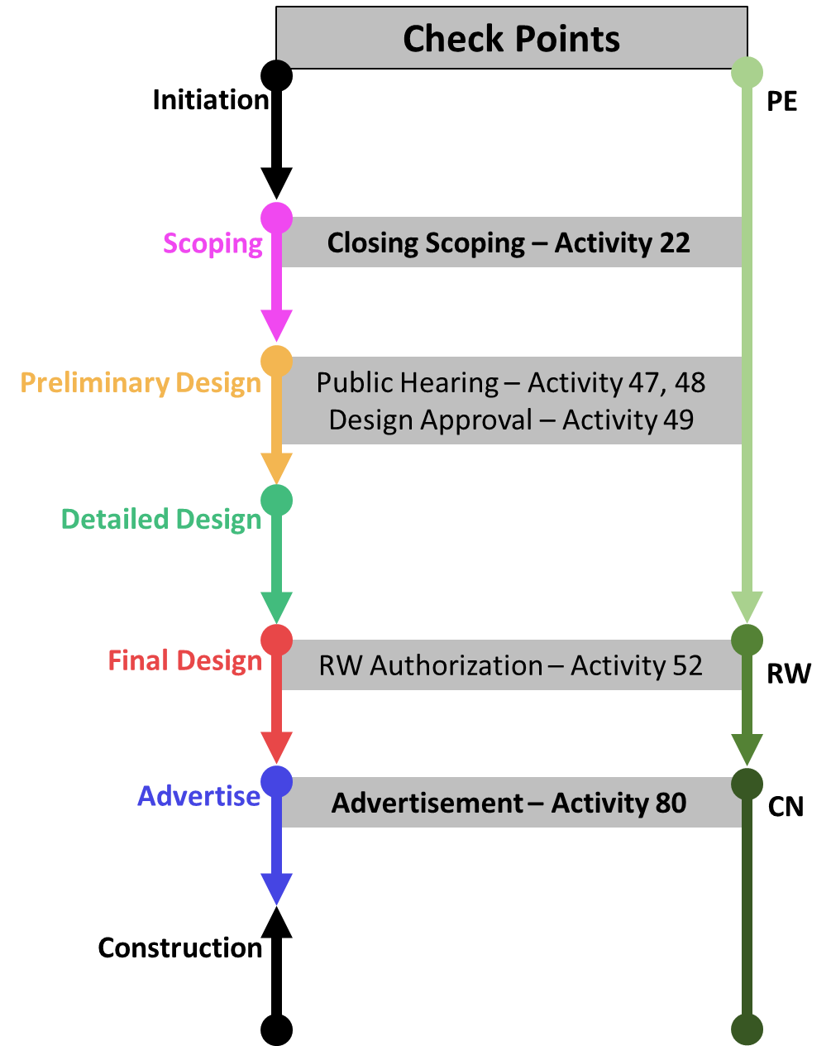

# Appendix B

## Illustrative List of Scope Changes

The following examples of scope changes are meant to be illustrative only and should not be considered an exhaustive list of all scope changes that could impact the project benefit calculation. The tables include when a review is needed and how it may impact the project benefits or the SMART SCALE score. The information provided below is intended to provide direction and should not be interpreted as CTB Policy.

As stated previously the expectation for managing any potential scope changes is for designated points of contact to reach out to the Statewide SMART SCALE Project Change Coordinator for review.

### Added Scope

Per the CTB SMART SCALE Policy: If the project scope is increased then the applicant is responsible for the additional cost attributable to the increase in scope regardless of budget impact. The scope of a project may not be substantially modified in such a manner that the proposed improvements do not accomplish the same benefits as the original scope.

If the working project scope includes scope elements not specifically detailed in the SMART SCALE application, then please reach out to any of the following: the District SMART SCALE Project Change Coordinator, the DRPT SMART SCALE Project Change Coordinator, or the Statewide SMART SCALE Project Change Coordinator.

Table B1: General Project Scope Changes

|  |  |  |
| --- | --- | --- |
| Description | Affected Measure | Trigger Review |
| Required Roadway Signage | None | No |
| Guardrail | None | No |
| Required Stormwater Management/Sound Barriers | None | No |
| Landscaping/Streetscaping* | None | No |
| Right-of –Way/Utilities Relocation | None | No |
| Non-standard materials* | None | Yes |
| Reduction in length of improvement/project termini | Safety; Congestion; Accessibility; ED- Reliability | Yes |

If not accounted for in the original project description or project features and budget then items such as these are not allowed unless the cost associated with the scope change is covered by the applicant.

Table B2: Multimodal Features

|  |  |  |
| --- | --- | --- |
| Description | Affected Measure | Trigger Review |
| Addition or Elimination of bike/pedestrian components | Accessibility; Land Use Environment; Safety (if only improvement of project) | Yes |
| Elimination of TDM (park and ride) or transit components or 15% or greater reduction in # of spaces or transit capacity | Safety; Congestion; Accessibility; Land Use; Environment; ED-Reliability | Yes |
| Reduction in transit (bus or rail) service frequency during peak hour (For example: 3 trains in peak hour to 2 or 3 buses in peak hour to 2) - before implementation | Safety; Congestion; Accessibility; ED-Reliability | Yes |
| Reduction in rolling stock capacity of any amount (For example 8 car train to 6 car train) | Safety; Congestion; Accessibility; ED-Reliability | Yes |
| Greater than 20% reduction in forecasted ridership during peak hour or in forecasted daily ridership | Safety; Congestion; Accessibility; ED-Reliability | Yes |
| Conversions between sidewalk, bike lanes, or shared use path | None | No |
| Change in location for proposed transit stop | None | No |

Table B3: Changes in Intersection/Interchange Treatments

|  |  |  |
| --- | --- | --- |
| Description | Affected Measure | Trigger Review |
| Elimination of or significant modification to Intersection feature (Traditional or Innovative):  Addition of lanes  Modification to allow full movement  Increasing # of signal phases (example - go from 2 to 4 phase) | Safety; Congestion, Economic Development | Yes |
| Changing grade separated interchange to an at-grade intersection | Safety; Congestion; Economic Development | Yes |
| Grade separated interchange - changing the number of ramp lanes and/or traffic control at the ramp terminal | Safety; Congestion; Economic Development | Yes |
| Adjusting the length of proposed turn lanes | None | No |
| Addition of RIRO entrance that does not trigger an access management waiver | None | No |
| Elimination of access management features - increase in number of full movement access points or inclusion of access point that would require an access management waiver | Safety; Congestion | Yes |

Table B4: Changes in Roadway Segments

|  |  |  |
| --- | --- | --- |
| Description | Affected Measure | Trigger Review |
| Add or remove number of through or auxiliary lanes | Safety; Congestion; Accessibility; ED-Reliability | Yes |
| Add or Remove proposed Road Diet | Safety; Congestion; Accessibility; ED-Reliability | Yes |
| Adjusting proposed Roadway Alignment | Safety | Yes |
| Adjusting the travel lane or shoulder width 2 feet or more | Safety; Congestion | Yes |

# Appendix C: Project Change Requested Materials

The following lists detail what materials are requested when submitting a project change for consideration. When submitting information for a Project Change, provide information to the Statewide SMART SCALE Project Change Coordinator.

Requested materials for a scope change (increase or decrease):

* Original project sketch
* Revised project sketch
* Description of the project change
* Justification of the project change
* Impact to the project budget

Requested materials for a budget change (increase):

* Original project budget
* Original SMART SCALE budget
* Revised budget
* Justification of the budget increase
* Funding identified to address budget shortfall